“Smart Plant Pot”

This week, I came up with the “Smart Plant Pot” idea. The initial idea was an indoor plant pot, integrated with sensors, which detect human presence in a room. If it detects that no one’s in the room, it will turn off unused appliances in its immediate vicinity.

The idea of a “plant” controlling house hold appliance was made to connect energy usage and how it affects the environment. After the first tutorial, it was suggested that the connection of the plant and its job was off from the topic of connected homes and internet of things.

To approach this, I decided to develop the “Smart Plant Pot” idea to an internet connected device which gathers information from the MET Office and informs its user accordingly. The idea is that the plant will gather weather and pollen count information from the website, and then feed the necessary information to its user.

The information is fed to the user using coded light signals. For example, the pot will light up as green on a “good” day, “blue” for a rainy day (hence reminding the user to carry an umbrella and wear a weather appropriate clothes) and “green” for high pollen count day (hence suggesting the user carry appropriate hay fever remedy).

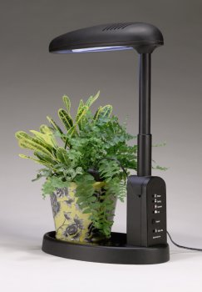

The actual design for this idea is not yet produced as I lacked the necessary part to build the prototype’s wiring. However, the code and how the idea is going to be demonstrated is already complete. At the moment, a paper model is used to represent the idea and I intend to make a better model by the end of this week. The electrical parts that I lack today will be sourced from “Makespace” today, as Ali wasn’t available last week to help with my project.

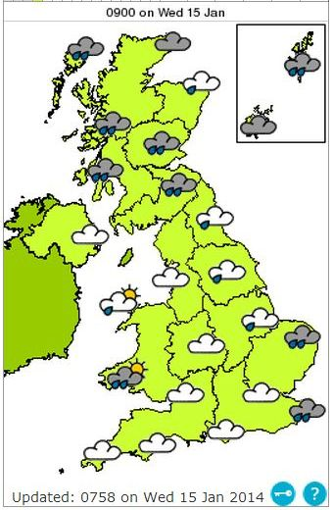

The move to this idea was chosen after conducting some product research online. According to a recent study, the most done activity on smartphones is checking the weather [1]. Even though the task of checking the weather is quite simple, the study still found that 47% of phone users constantly use their devices to check this information.

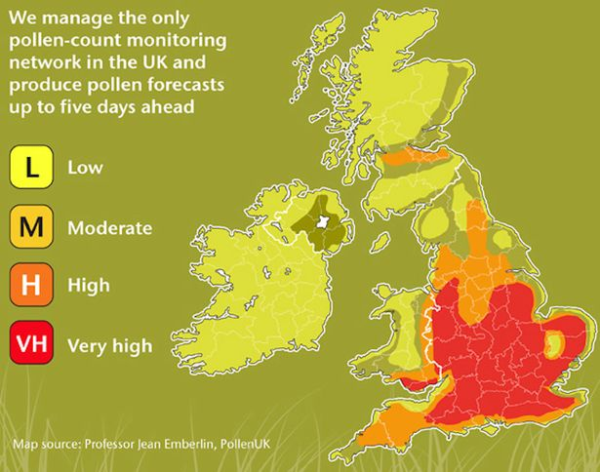

The pollen monitoring and warning is integrated to the “Smart Plant Pot” idea as pollens are quite connected to plants. Even though its counterintuitive to have an indoor plant, for people with pollen allergies, a study conducted by NASA states that some plants are quite useful for relieving allergies and filtering indoor air pollutants. [2]

My plan for this week is to produce a model for this idea which will demonstrate how it will work.

[1] <http://www.huffingtonpost.com/2012/08/21/the-number-one-use-smartphone_n_1818632.html>

* Weather is popular

[2] <http://www.gardeningknowhow.com/houseplants/hpgen/houseplants-for-allergies.htm>

- Indoor plants are safe from pollen (if taken care of properly)

[3] https://ntrs.nasa.gov/archive/nasa/casi.ntrs.nasa.gov/19930073077.pdf

* Indoor plants are safe from pollen (if taken care of properly)

[4] <http://www.metoffice.gov.uk/health/public/pollen-forecast>

* Pollen Count

[5] <http://www.metoffice.gov.uk/public/weather/forecast>

* Weather